Printing Patterns

Problem: Write a Java program to print patterns such as a right triangle of stars.

Test Cases:

Input: n = 3

Output:

\*

\*\*

\*\*\*

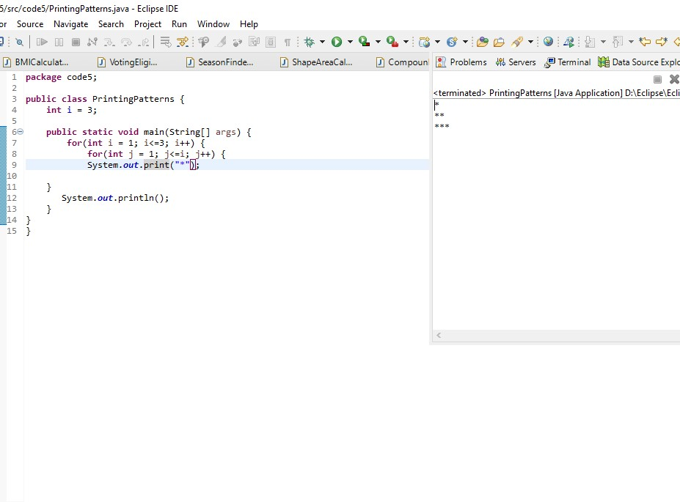

2. Remove Array Duplicates

Problem: Write a Java program to remove duplicates from a sorted array and return the new length of the array.

Test Cases:

Input: arr = [1, 1, 2]

Output: 2

Input: arr = [0, 0, 1, 1, 2, 2, 3, 3]

Output 4

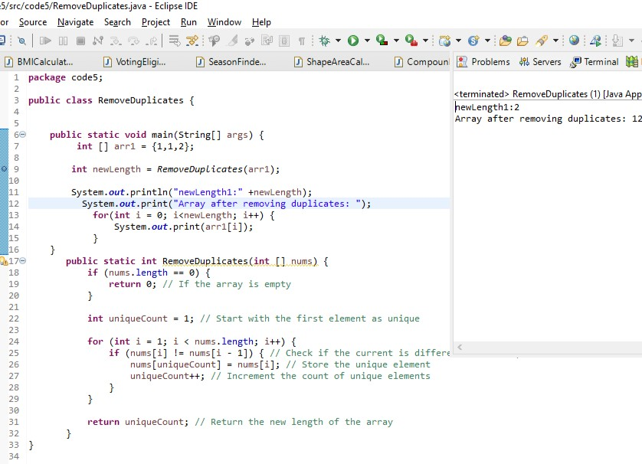

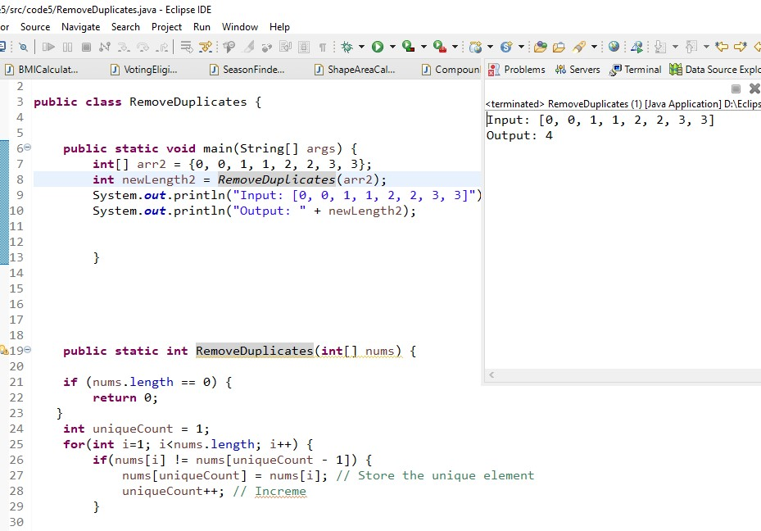

. Remove White Spaces from String

Problem: Write a Java program to remove all white spaces from a given string.

Test Cases:

Input: "Hello World"

Output: "HelloWorld"

Input: " Java Programming "

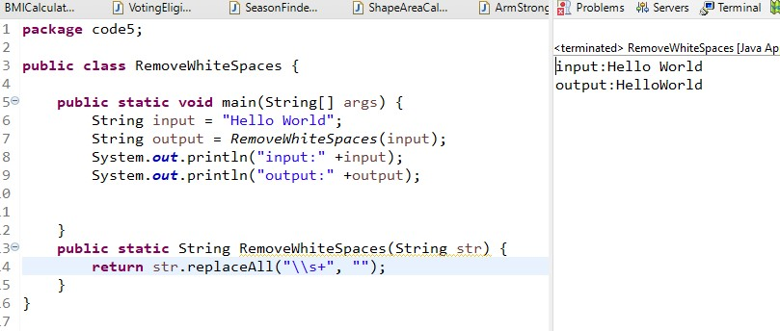

4. Reverse a String

Problem: Write a Java program to reverse a given string.

Reverse Array in Place

Problem: Write a Java program to reverse an array in place.

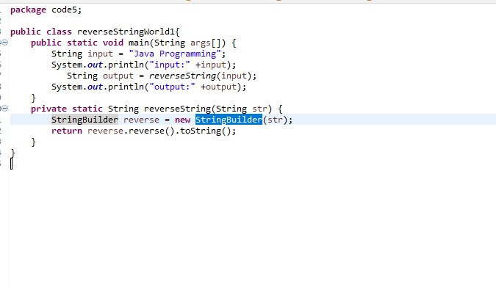

Reverse Array in Place

Problem: Write a Java program to reverse an array in place.

